ethics

objectives

The students will:

1. Identify the importance and impact of ethics on the fire department/emergency medical services (EMS) and its members.

2. Identify the role of the fire/EMT officer in establishing, modeling, and managing ethical behavior.

3. Analyze their own department's existing ethical rules and guidelines, and where the gaps might be.

4. Demonstrate decisionmaking involving ethical practices.

Activity ET.1

Ethics at Any Level

Purpose

To identify the importance and impact of ethics on the fire department/emergency medical services (EMS) and its members.

Directions

1. Read the following scenario, which illustrates several typical ethical dilemmas any fire/ EMS officer might face.

2. After reading the scenario, should put it away for use later in the module.

Scenario

You are the Chief Officer in Strafford County. Within the county is the city of Clarkmont, which has its own career fire/EMS department. Your duties involve oversight of the 9-1-1 center, emergency management, and coordination of the workings of ten volunteer departments to the south and west of Clarkmont. Mutual aid is in place. Upon taking this position you were under the impression that there was a good working relationship within and among the various volunteer departments who receive a mill tax from the county, as well as revenue from other fundraising events. Part of your job is to insure that volunteer departments are meeting standards before disbursing money as you finalize your budget. You get a call from a local newspaper.

The reporter is working on a story and asks for some input from you. Allegedly "The Wayward Volunteer Department" has violated its own rules. The president of the department has the authority to fire any volunteers who miss calls and do not pay annual dues of $10 by the end of the month. The reporter says that at the meeting the previous night, the president fired six of its younger members, and it is only the 5th of the month. All six live in the district and are career fire/EMS personnel. They have excellent records of participation, especially on their nonduty days when the department is understaffed. The reporter contacted the president, who said "they did not pay their dues on time" and "we can always get mutual aid from Bellevue and Greenleaf…" as well as two other departments whose name was not mentioned. The reporter further states that the people who called the paper said those departments are as far as 20 minutes away and usually respond via an old highway, which is very difficult to drive on, especially in the winter.

You have heard rumors that the president, who has been in power for over 30 years and has created an "old dogs" network, playing favorites with the buddies, is fearful that the younger group will try to replace the president in a job for which there isn't a salary but enjoys standing within the community. Without divulging to the reporter that you have heard this rumor, you state you will investigate and ask for names of those who complained. The reporter refuses to divulge sources but says the minutes of the meeting mysteriously disappeared when trying to access them under the Freedom of Information Act.

i. ethics and their impact

A. What is the meaning of ethics?

1. A given system of conduct.

2. Principles of honor or morality.

3. Guidelines for human action.

4. Rules or standards.

5. Expected behavior.

B. Ethics have roots in:

1. Ancient history.

2. Religion.

3. Systems of law.

4. Social customs.

5. Personal code of conduct.

C. Codes of ethics are standards of behavior for:

1. Professional life.

2. Relations with the public.

3. Relations with employers.

4. Relations with coworkers.

II. Sample Code of Ethics

The American Society for Public Administration (ASPA) exists to advance the science, processes, and art of public administration. ASPA encourages professionalism and improved quality of service at all levels of government, education, and the not-for-profit private sector. ASPA contributes to the analysis, understanding, and resolution of public issues by providing programs, services, policy studies, conferences, and publications.

ASPA members share with their neighbors all of the responsibilities and rights of citizenship in a democratic society. However, the mission and goals of ASPA call every member to additional dedication and commitment. Certain principles and moral standards must guide the conduct of ASPA members not merely in preventing wrong, in pursuing right through timely and energetic execution of responsibilities.

To this end, we, the members of the Society, recognizing the critical role of conscience in choosing among courses of action and taking into account the moral ambiguities of life, commit ourselves to:

A. Serve the public interest.

Serve the public, beyond serving oneself. ASPA members are committed to:
1. Exercise discretionary authority to promote the public interest.

2. Oppose all forms of discrimination and harassment, and promote affirmative action.

3. Recognize and support the public's right to know the public's business.

4. Involve citizens in policy decisionmaking.

5. Exercise compassion, benevolence, fairness, and optimism.

6. Respond to the public in ways that are complete, clear, and easy to understand.

7. Assist citizens in their dealings with government.

8. Be prepared to make decisions that may not be popular.

B. Respect the Constitution and the law.

Respect, support, and study government constitutions and laws that define responsibilities of public agencies, employees, and all citizens. ASPA members are committed to:

1. Understand and apply legislation and regulations relevant to their professional role.

2. Work to improve and change laws and policies that are counterproductive or obsolete.

3. Eliminate unlawful discrimination.

4. Prevent all forms of mismanagement of public funds by establishing and maintaining strong fiscal and management controls, and by supporting audits and investigative activities.

5. Respect and protect privileged information.

6. Encourage and facilitate legitimate dissent activities in government and protect the whistle blowing rights of public employees.

7. Promote constitutional principles of equality, fairness, representativeness, responsiveness, and due process in protecting citizens' rights.

C. Demonstrate personal integrity.

Demonstrate the highest standards in all activities to inspire public confidence and trust in public service. ASPA members are committed to:

1. Maintain truthfulness and honesty and to not compromise them for advancement, honor, or personal gain.

2. Ensure that others receive credit for their work and contributions.

3. Zealously guard against conflict of interest or its appearance: e.g., nepotism, improper outside employment, misuse of public resources, or the acceptance of gifts.

4. Respect superiors, subordinates, colleagues, and the public.

5. Take responsibility for their own errors.

6. Conduct official acts without partisanship.

D. Promote ethical organizations.

Strengthen organizational capabilities to apply ethics, efficiency, and effectiveness in serving the public. ASPA members are committed to:

1. Enhance organizational capacity for open communication, creativity, and dedication.

2. Subordinate institutional loyalties to the public good.

3. Establish procedures that promote ethical behavior and hold individuals and organizations accountable for their conduct.

4. Provide organization members with an administrative means for dissent, assurance of due process, and safeguards against reprisal.

5. Promote merit principles that protect against arbitrary and capricious actions.

6. Promote organizational accountability through appropriate controls and procedures.

7. Encourage organizations to adopt, distribute, and periodically review a code of ethics as a living document.

E. Strive for professional excellence.

Strengthen individual capabilities and encourage the professional development of others. ASPA members are committed to:

1. Provide support and encouragement to upgrade competence.

2. Accept as a personal duty the responsibility to keep up to date on emerging issues and potential problems.

3. Encourage others, throughout their careers, to participate in professional activities and associations.

4. Allocate time to meet with students and provide a bridge between classroom studies and the realities of public service.

Activity ET.2

Differing Expectations and Ethical Conflicts

Purpose

To demonstrate decisionmaking involving ethical practices.

Directions

1. In your small group, discuss your assigned scenario, the formal expectations, and the informal expectations.

2. Determine the ethical considerations if informal expectations are allowed to continue.

3. The following scenarios describe situations in which formal (organizational) expectations conflict with informal expectations of the public, a supervisor, subordinates, or oneself. Differing expectations often create ethical conflicts which need to be resolved.

4. Determine how a Company Officer (CO) should handle the situation.

5. List your results and select a spokesperson to report on your ethical considerations and the resolution of the situation.

6. You have 10 minutes to complete the exercise.

Activity ET.2 (cont'd)

Worksheet

Group 1: Community Expectations

Scenario: Your fire/EMS station, located next door to the public tennis courts, has always had citizens come into the station to use the restrooms, water fountain, and cold drink machine. During the summer, cold drink sales made enough money to buy a television set for the rec room. Since the city recently installed lighting for the courts, citizens frequently come in during the evenings. Several attractive youths have been spending a few hours after playing tennis watching television and joking around with the crew members of the company.

Informal Expectations of Involved Citizens and Subordinates

The fire station is public property and therefore open to the public. They are not interfering with official activities and are causing no harm.

Formal Expectations (Official Department Policy)

Visitors to the fire station should be approved by the station officer and the duration of visits should be limited to the time it takes to conduct whatever business is needed.

Ethical Considerations | How Should the CO Handle?
1.
2.
3.

Group 2: Supervisor's Expectations

Scenario: The battalion chief, when visiting your fire station, usually spends a half hour or more talking about the fire chief in a very negative manner. The battalion chief finds fault with every order or policy that comes from the chief's office. The members of your company think the battalion chief is great because of the understanding of how they think and feel.

Informal Expectations of Involved Citizens and Subordinates

The battalion chief has a duty to keep all members of their battalion informed about the orders and policies of the department and they also have the right to add personal opinions to policy matters.

Formal Expectations (Official Department Policy)

All members of the department should demonstrate loyalty to the department, their superiors, their subordinates, and to each other.

Ethical Considerations | How Should the CO Handle?
1.
2.
3.

Group 3: Subordinates Expectations

Scenario: For many years, several times a week, your company has stopped by a local ice cream parlor for ice cream cones. The owner doesn't discount the price, but does give double scoops at no extra charge to the firefighters/emergency medical technicians (EMTs).

Informal Expectations of Involved Citizens and Subordinates

This stop for ice cream has become somewhat of a tradition of this company. No one sees any problem if the store owner wants to give a little extra to the firefighters/EMTs who stop by.

Formal Expectations (Official Department Policy)

No member of the department shall accept any tips, gratuities, presents, money, etc., as representatives of the department.

Ethical Considerations | How Should the CO Handle?
1.
2.
3.

Group 4: Self-Expectations

Scenario: A new firefighter recently graduated from recruit school and has been assigned to a CO at a different station from yours. The officer does not know the new recruit is a member of your family. Today at a critique you both attended, this lieutenant mentioned that someone is pilfering some station supplies and the new recruit is suspected and will be watched over the next several days to try and catch him in the act. This would result in the new recruit's termination.

Informal Expectations of Involved Citizens and Subordinates

This is a family member and I owe my family a warning.

Formal Expectations (Official Department Policy)

Any member caught stealing will be immediately suspended without pay and criminal charges sought by the department.

Ethical Considerations | How Should the CO Handle?
1.
2.
3.

Activity ET.3

Ethical Decisionmaking

Purpose

To examine the day-to-day ethics of a group to determine: consistency, agreement, and differences. To discover the actual principles or culture and values that influence certain decisions in the group, and to discover if there is an impact on decisions by missions, goals, policies, procedures, training, performance standards, etc. To provide an actual opportunity to wrestle with some tough day-to-day decisions, calling into play both personal and organizational ethics.

Directions

1. In your small group select one person to act as coordinator/timekeeper.

2. Each person, including the coordinator, lists all others in the group (minus coordinator) on the Ethical Decisionmaking Worksheet.

3. The first volunteer reads the scenario (privately), and has 2 minutes to decide a course of action. If the options are not acceptable, a new one can be created. Each person should decide what is ethical (proper and right) for the situation "in the real world."

4. The coordinator will read the scenario aloud, give the decision made, and explain why that option was chosen. (1 minute.)

5. Without discussion, others in the group score on the worksheet how much they agree with the choice and the reasons for it. (1 minute.)

6. Group members then tell the decisionmaker what scores they gave and why.

7. The group then has 5 minutes to question the decisionmaker and ask for justification of the choice. (Why that option? Why not others?) Do not try to solve the original problem or avoid it. Discuss the ethics of the decision made.

8. The coordinator moves on to the next decisionmaker, who picks a scenario. The process is repeated until all (including the coordinator) have made an ethical decision and justified it to the group.

Activity ET.3 (cont'd)

Ethical Decisionmaking Worksheet

Scoring
1 | 2 | 3 |  | 4 | 5 |  | 6 | 7 |  | 8 | 9 | 10
< | < | < |  | < |  |  |  | > |  | > | > | >
Shades of Disagreement |  |  |  |  |  |  | Shades of Agreement
I totally disagree with your choice and your reasons. |  |  |  |  | I accept your choice, but disagree with why you chose that option. |  |  |  | I totally agree with you on your choice and your reasons.
Group Members |  |  | Score I Gave to Decision |  |  | Scores Others Gave
1.
2.
3.
4.

When you have completed one round, discuss the following questions:

1. What makes ethical decisions difficult?

2. How much difference or similarity were there in the scores and why?

3. What did your group learn from this exercise?

iIi. guidelines and resources

A. Recap.

1. Many people have a stake in decisions.

2. Different people may have legitimate but contradictory expectations.

3. The fire/EMS officer's own personal ethics count too.

4. Ethical decisions need to consider community/organizational/personal standards.

5. The clearer the standards, the easier the decision.

B. Evaluating available resources/guidelines can help you resolve ethical dilemmas.

Activity ET.1 (Revisited)

Guidelines and Resources to Assist in Decisionmaking

Scenario

Point out that the following scenario illustrates several typical ethical dilemmas any Officer might face.

You are a Chief Officer in a Strafford County. Within the county are is the city of Clarkmont which has its own career fire department/EMT. Your duties involve oversight of the 9-1-1 center, emergency management and coordination of the workings of ten volunteer departments which are around and mostly to the south and west of Clarkmont. Mutual aid is in place. Upon taking this position you were under the impression that there was a good working relationship within and among the various volunteer departments who receive a mill tax from the county in addition to other fundraising events. Part of your job is to insure volunteer departments are meeting standards before disbursing money and as you are finalizing your budget. You get a call from a local news paper.

The reporter tells you she is working on a story and asks for some input. Allegedly "The Wayward Volunteer Department" has violated its own rules. The president of the department has the authority to fire any volunteers who miss calls and do not pay annual dues of $10 by the end of the month. She says that at the meeting the previous night, the president fired six of its younger members and it is only the 5th of the month. All six live in the district are career fire/ EMT people from surrounding cities and counties and have excellent records of participation especially on their nonduty days when the department is understaffed. The reporter contacted the president who said "they did not pay their dues on time" and we can always get mutual aid from Bellevue, Greenleaf and two other departments whose name he did not know. She further states that the people who called her paper said those departments are as far as 20 minutes away and usually respond via an old highway, which is very difficult to drive on, especially in the winter.

[Without divulging to her you have heard rumors of the president who has been in power for over 30 years creating an "old boy" network and playing favorites with his buddies but is afraid the younger group will try to replace him in a job for which he gets no salary but standing within the community.] You inform her you will investigate and ask for names of those who complained. She refuses to divulge sources but says the minutes of the meeting mysteriously disappeared when she tried to access them under the Freedom of Information Act.

Do you investigate? If not, why not?

How do you involve the supposedly aggrieved and "fired" volunteer members?

Do you get the county manager involved due to political ramifications?

Do you demand immediate resignation of current president and Board members of the Wayward Department?

Other(s)?

III. guidelines and resources (cont'd)

C. An ethical decision will:

1. Honor formal department decisions and documents.

2. Not violate laws, rules, etc.

3. Reflect reasonable and positive cultural characteristics.

4. Reflect the interest of all parties as much as possible.

5. Feel right!

IV. Characteristics of ethical organization and an ethical leader

A. Characteristics of an ethical organization.

1. Senior management defines and clarifies standards, values, and ethics.

2. Senior management demonstrates a commitment to those ethics, expects a similar commitment of all members.

3. The organization supports and rewards ethical behavior and ethical solutions to problems.

4. The organization gives consideration to all stakeholders--the community, policymakers, employees, and special interest groups.

5. The organization as a whole prides itself on its ideals and on striving toward them.

- Characteristics of an ethical leader.

1. Models ethical behavior after others.

2. Attempts to balance personal ethics with those of the organization.

3. Considers impact of decisions on all others who will be affected.

4. Operates with integrity, honesty, and courage.

5. Approaches ethics from a positive point of view, guided by their own ethical compass or conscience.

- Test of an ethical decision.

1. Do I feel unembarrassed, unashamed, not guilty, or not defensive?

2. Do I object to my decision being published openly?

3. Am I willing to risk criticism for my decision?

4. Could I justify and defend my decision to my greatest critics and enemies?

5. Have I considered all who would be affected by the decision and given them proper priority or weight?

6. Does it feel right in my gut--is my conscience clear?

Introduction

The issue of ethics is one that has a direct impact on the fire/EMT service middle manager or CO. The CO must make decisions, provide guidance and leadership, and set an example for subordinates in the context of what is right/wrong, acceptable/unacceptable, or good/bad.

The ethical standards of the fire department/EMT are influenced by what society in general expects, what the local community believes is the job of the fire department/EMT, and by numerous laws, codes, and other standards of behavior. Each department's ethics also mirror what is valued and rewarded, as well as what is not valued and therefore penalized. This internal value system or culture is a powerful regulator of ethics, and can be a help or a hindrance to the CO trying to do the right thing in all situations. It is not an easy job!

The key concepts of this module are

- That personal and professional ethics are shaped by such differing sources as:

- Our family's values and culture.

- Community attitudes, including conflicting social and economic expectations.

- The U.S. Constitution and Bill of Rights, and numerous laws, codes, and ordinances.

- Religious beliefs and teachings.

- Our life and work experience, including the standards, beliefs, and attitudes of peers, superiors, subordinates, and policymakers.

- That ethics and standards change, causing ethical dilemmas for fire department/EMT officers. For example, until recently the dumping of hazardous wastes was rather casual and considered "OK" if done economically and short distances from human activity. Now, with changing public attitudes, new legislation, and rigid restrictions, fire department/EMTs must be prepared to enforce the law, mitigate unsafe storage and transport, and carry out tricky cleanup of hazardous materials spills. Ethical questions arise about the acceptable level of exposure to firefighters/EMTs and other emergency personnel. The acquired immunodeficiency syndrome (AIDS) epidemic is causing similar soul-searching as well as changes in policies and procedures.

- That codes of ethics can only serve as rough guidelines for ethical decisions, since day-to-day ethical dilemmas cannot be specifically anticipated and solved with a formula. Rather, COs must rely on numerous sources of guidance for decisions, and anticipate gaps or organizational blind spots where no explicit guidelines exist to help with decisions.

- That midmanagers or COs play a difficult and key role in managing and influencing the day-to-day operational ethics of the department. For example, they are primarily responsible for ensuring that the community gets their money's worth (return on investment) by the effective use of personnel, materials, and time on a day-to-day or shift-to-shift basis.

- That fire/EMS officers, with proper planning and foresight, can avoid falling into ethical traps that would haunt them throughout their fire/EMS careers.

ethics and their impact

Introduction

One of the greatest desires of most fire/EMS officers is to provide service in an honorable way and to follow a long history of leaders who performed great good to great numbers of people. This module will assist you in sorting out the ethical demands placed upon you, and in preparing for ethical challenges in the future.

Ethics

What is the meaning of ethics? Dictionaries define ethics as a given system of conduct; principles of honor or morality; guidelines for human actions; rules or standards for individuals or professions; and the character of a group based on its agreements about what is proper or expected behavior.

Ethics have roots in ancient history, religion, systems of law, social customs, and our own personal code of conduct.

Ancient History

The Greek culture adopted rules for its citizens, such as "Do the greatest good for the greatest number."

Religion

- All of the great religions of the world have the equivalent of the "Ten Commandments" to guide the thinking and actions of their members.

- These guidelines specifically state how people should act, especially in relationships with other human beings.

- The golden rule, "do unto others as you would have them do unto you," is universal, as are universal values of honesty, courage, justice, tolerance, and full use of talents.

Systems of Law

- Laws summarize decisions of technically trained judges as well as juries of peers who decide if a wrong has been committed.

- New laws also arise as the values and attitudes of the community change.

- Ethics often begin where the law leaves off.

Social Customs

- Define what is acceptable and unacceptable in a certain community.

- Members of any community either condone (support) or condemn (resist) specific actions.

- There is a vast difference between which standards are upheld and which are relaxed. Within some fire department/EMS, a state of constant readiness means equipment only; in others, the standard also includes the physical and mental readiness of all personnel.

Our Own Personal Code of Conduct

Based upon a very personal assessment of what's right or wrong, our code of conduct begins with early childhood and matures through our life experiences and the attitudes of people we respect, the confidence we have in our own standards, how often we've been supported or burned by past decisions, etc.

What is often described as a gut feeling about what's right has medical confirmation! Except for rare sociopaths, people receive a distinct message from the pit of their stomachs when either thinking about or doing what they believe to be wrong!

The galvanic skin response, used in the controversial but common lie detector test, takes advantage of this basic physiological response to truth or falsehood. It is similar to the fight or flight reflex we have when we are in a stressful situation. Our body alerts us to our most basic options!

Codes of Ethics

This arose over centuries to provide specific guidelines to members of a profession, craft, or business. They are designed to inform in-group members of a common set of standards, encouraging them to live by those standards. Their purpose is to protect the integrity and reputation of the whole group by publishing what is considered to be correct or expected behavior, and an individual's obligations to the group. A well-known code of ethics is the Hippocratic oath of physicians, which states in part, "Above all, do no harm."

Codes of ethics spell out standards of behavior for:

- Professional life--Example: "Recognize badge of office as a symbol of public faith, and accept it as a public trust to be held as long as s/he is true to the ethics of his/her office." (Fire Marshal's Association of America.)

- Relations with the public or society--Example: "Be courteous, considerate, enthusiastic, and cooperative. Be especially tactful and considerate in dealing with those who have experienced a loss due to fire." (Firefighter's Ten Commandments; Carl E. McCoy, author.)

- Relations with employers--Example: "Not accept, for the same service, compensation of any kind (other than from the client, principal, or employer) without full disclosure, knowledge, and consent of all parties concerned." (International Society of Fire Service Instructors.)

- Relations with other employees/coworkers--Examples: "Be honest in all my professional relationships." (Data Processing Management Association.) "Handle all matters of personnel on the basis of merit so that fairness and impartiality govern (a member's) decisions, pertaining to appointments, pay adjustments, promotions, and discipline." (International City Manager's Association) "Share benefits and responsibility; help each other." (Hewlett-Packard Co.) "Maintain the highest standards of personal integrity; be honest and straightforward in dealings with others, and avoid conflicts of interest." (International Association of Fire Chiefs.)

sample code of ethics

Serve the Public Interest

Serve the public, beyond serving oneself. ASPA members are committed to:

- Exercise discretionary authority to promote the public interest.

- Oppose all forms of discrimination and harassment, and promote affirmative action.

- Recognize and support the public's right to know the public's business.
- Involve citizens in policy decisionmaking.

- Exercise compassion, benevolence, fairness, and optimism.

- Respond to the public in ways that are complete, clear, and easy to understand.

- Assist citizens in their dealings with government.

- Be prepared to make decisions that may not be popular.

Respect the Constitution and the Law

Respect, support, and study government constitutions and laws that define responsibilities of public agencies, employees, and all citizens. ASPA members are committed to:

- Understand and apply legislation and regulations relevant to their professional role.

- Work to improve and change laws and policies that are counterproductive or obsolete.

- Eliminate unlawful discrimination.

- Prevent all forms of mismanagement of public funds by establishing and maintaining strong fiscal and management controls, and by supporting audits and investigative activities.

- Respect and protect privileged information.

- Encourage and facilitate legitimate dissent activities in government and protect the whistleblowing rights of public employees.

- Promote constitutional principles of equality, fairness, representativeness, responsiveness, and due process in protecting citizens' rights.

Demonstrate Personal Integrity

Demonstrate the highest standards in all activities to inspire public confidence and trust in public service. ASPA members are committed to:

- Maintain truthfulness and honesty and to not compromise them for advancement, honor, or personal gain.

- Ensure that others receive credit for their work and contributions.

- Zealously guard against conflict of interest or its appearance: e.g. nepotism, improper outside employment, misuses of public resources, or the acceptance of gifts.

- Respect superiors, subordinates, colleagues, and the public.

- Take responsibility for their own errors.

- Conduct official acts without partisanship.

Promote Ethical Organizations

Strengthen organizational capabilities to apply ethics, efficiency, and effectiveness in serving the public. ASPA members are committed to:

- Enhance organizational capacity for open communication, creativity, and dedication.

- Subordinate institutional loyalties to the public good.

- Establish procedures that promote ethical behavior and hold individuals and organizations accountable for their conduct.

- Provide organization members with an administrative means for dissent, assurance of due process, and safeguards against reprisal.

- Promote merit principles that protect against arbitrary and capricious actions.

- Promote organizational accountability through appropriate controls and procedures.

- Encourage organizations to adopt, distribute, and periodically review a code of ethics as a living document.

Strive for Professional Excellence

Strengthen organizational capabilities to apply ethics, efficiency and effectiveness in serving the public. ASPA members are committed to:

- Provide support and encouragement to upgrade competence.

- Accept as a personal duty the responsibility to keep up to date on emerging issues and potential problems.

- Encourage others, throughout their careers, to participate in professional activities and associations.

- Allocate time to meet with students and provide a bridge between classroom studies and the realities of public service.

guidelines and resources

Many groups (and individuals) have a stake in decisions. These groups may all have legitimate but contradictory needs. The fire/EMS officer's own personal ethics, standards, and integrity are always part of the picture.

There are numerous courses of action that a fire/EMS officer can take in making a decision. There is seldom a clear, totally right or wrong answer to ethical dilemmas. A person must base a decision on community, organizational, and/or personal standards. The clearer they are, the easier the decision!

Which guidelines currently exist in your fire department/EMS to guide and support your decisions and also determine what gaps might exist? All fire department/EMS, no matter how simple or sophisticated, have a unique jigsaw puzzle of values, standards, expectations, requirements, and legal mandates. These parts of the organizational whole directly reflect decisions that have been made in the past about what is right and wrong, proper and improper. Unfortunately, some of these decisions have been made officially and some have been made unofficially, based on the culture and values of the members of the department. This makes it difficult for a fire/EMS officer to sort out the formal from the informal, to clarify standards, and to arrive at ethically proper decisions.

What exists in your fire department/EMS right now that helps and guides you in ethical matters? What sets the standards for day-to-day decisions? Use the blank "Checklist for Ethical Decisions" at the end of the module to help resolve any ethical dilemma you face.

Although there are numerous guideposts to assist with decisionmaking, many of them point in conflicting directions!

Presumably, the more formal the guidelines that exist in the department, the more help an officer has in making decisions. Not necessarily so! Sometimes past organizational decisions are not consistent; they are also contradictory. Serious review of department documents and culture may only confuse the responsible officer.

In the final analysis, the bottom line is that each person must weigh and honor existing guidelines, but make the decision based on his/her own personal ethics, ideals, and convictions.

There are no formulas for the grey areas, or for the tough decisions. A major part of ethical behavior is accepting that you must do what you believe is right, given the specific situation, and be prepared to justify and defend your decision if necessary.

An Ethical Decision

Ethics decisions will

- honor formal department decisions and documents;
- not violate laws, rules, etc;
- reflect reasonable and positive cultural characteristics;
- reflect the interest of all parties as much as possible; and
- feel right!

Characteristics of an Ethical Organization and an Ethical Leader

Characteristics of an Ethical Organization

- Senior management defines and clarifies standards, values, and ethics.

- Senior management demonstrates a commitment to those ethics and expects a similar commitment of all members.

- The organization supports and rewards ethical behavior and ethical solutions to problems.

- The organization gives consideration to all stakeholders--the community, policymakers, employees, and special interest groups.

- The organization as a whole prides itself on its ideals and on striving toward them.

Characteristics of an Ethical Leader

- Models ethical behavior after others.

- Attempts to balance personal ethics with those of the organization.

- Considers impact of decisions on all others who will be affected.

- Operates with integrity, honesty, and courage.

- Approaches ethics from a positive point of view, guided by his/her own ethical compass or conscience.

Tests of an Ethical Decision (Organizational or Personal)

- Do I feel unembarrassed, unashamed, not guilty, or not defensive?
- Do I object to my decision being published openly?

- Am I willing to risk criticism for my decision?

- Could I justify and defend my decision to my greatest critics and enemies?

- Have I considered all who would be affected by the decision and given them proper priority or weight?

- Does it feel right in my gut--is my conscience clear?

summary

"Ideals are like stars--we never reach them.
But, like mariners at sea, we chart our course by them."
-- Author unknown

"…Men (and women) often stumble over the truth, and most manage to pick themselves up and hurry off as if nothing had happened."
--Winston Churchill

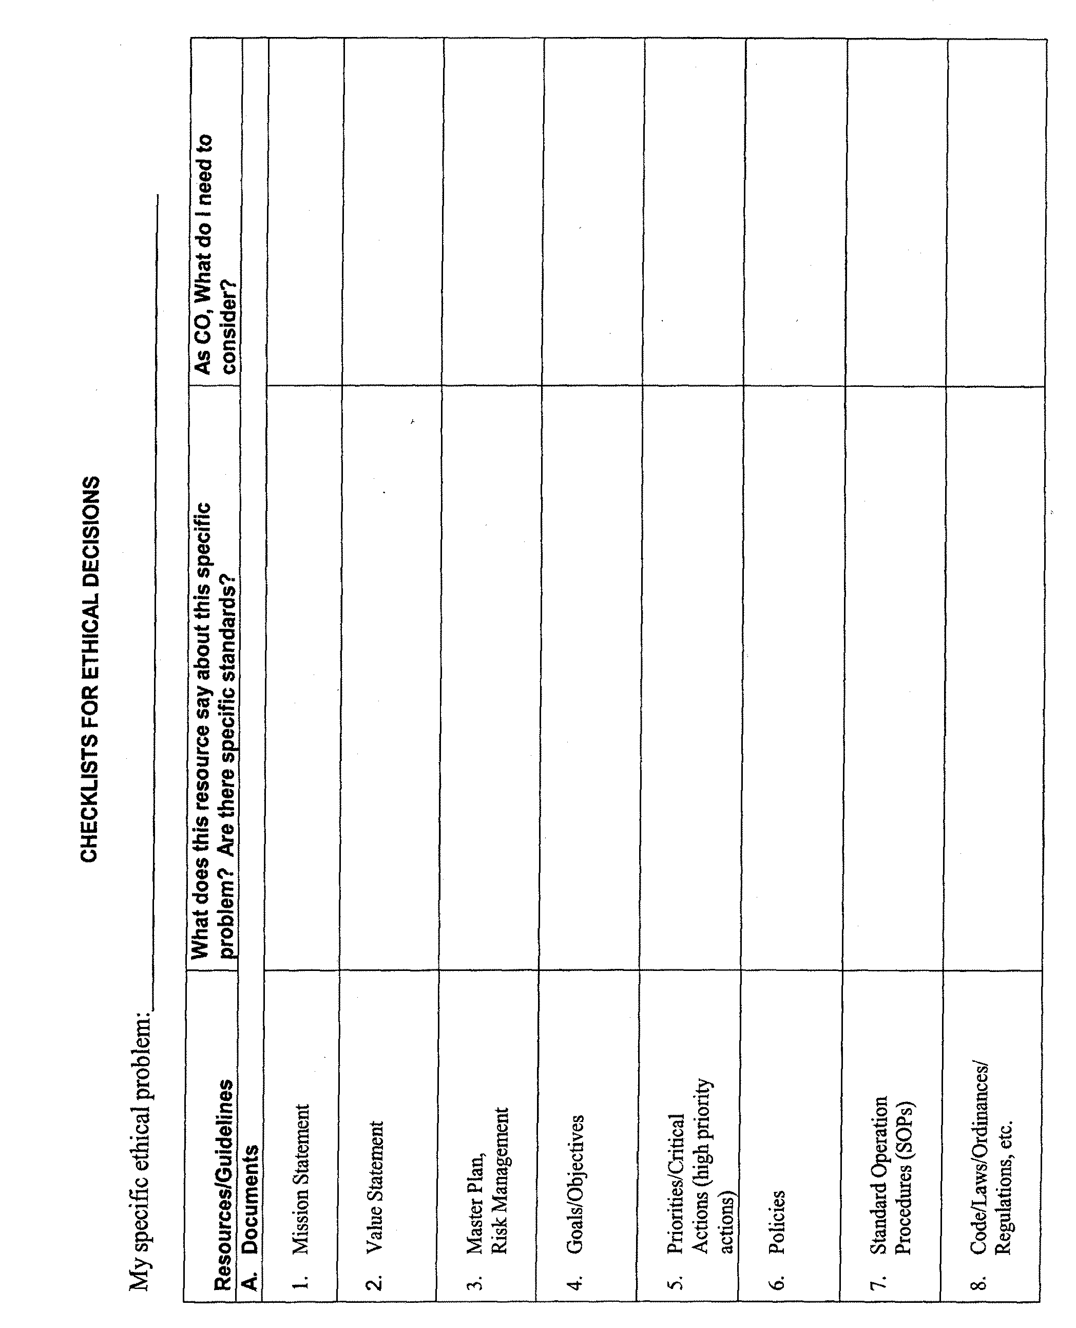

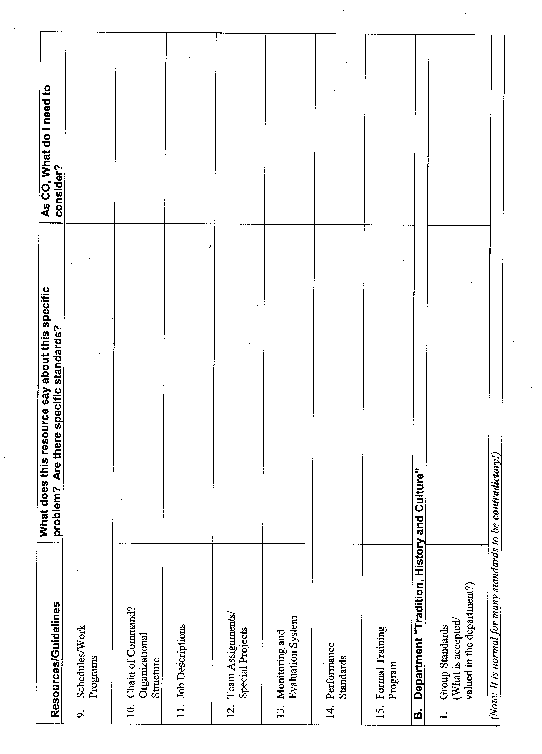
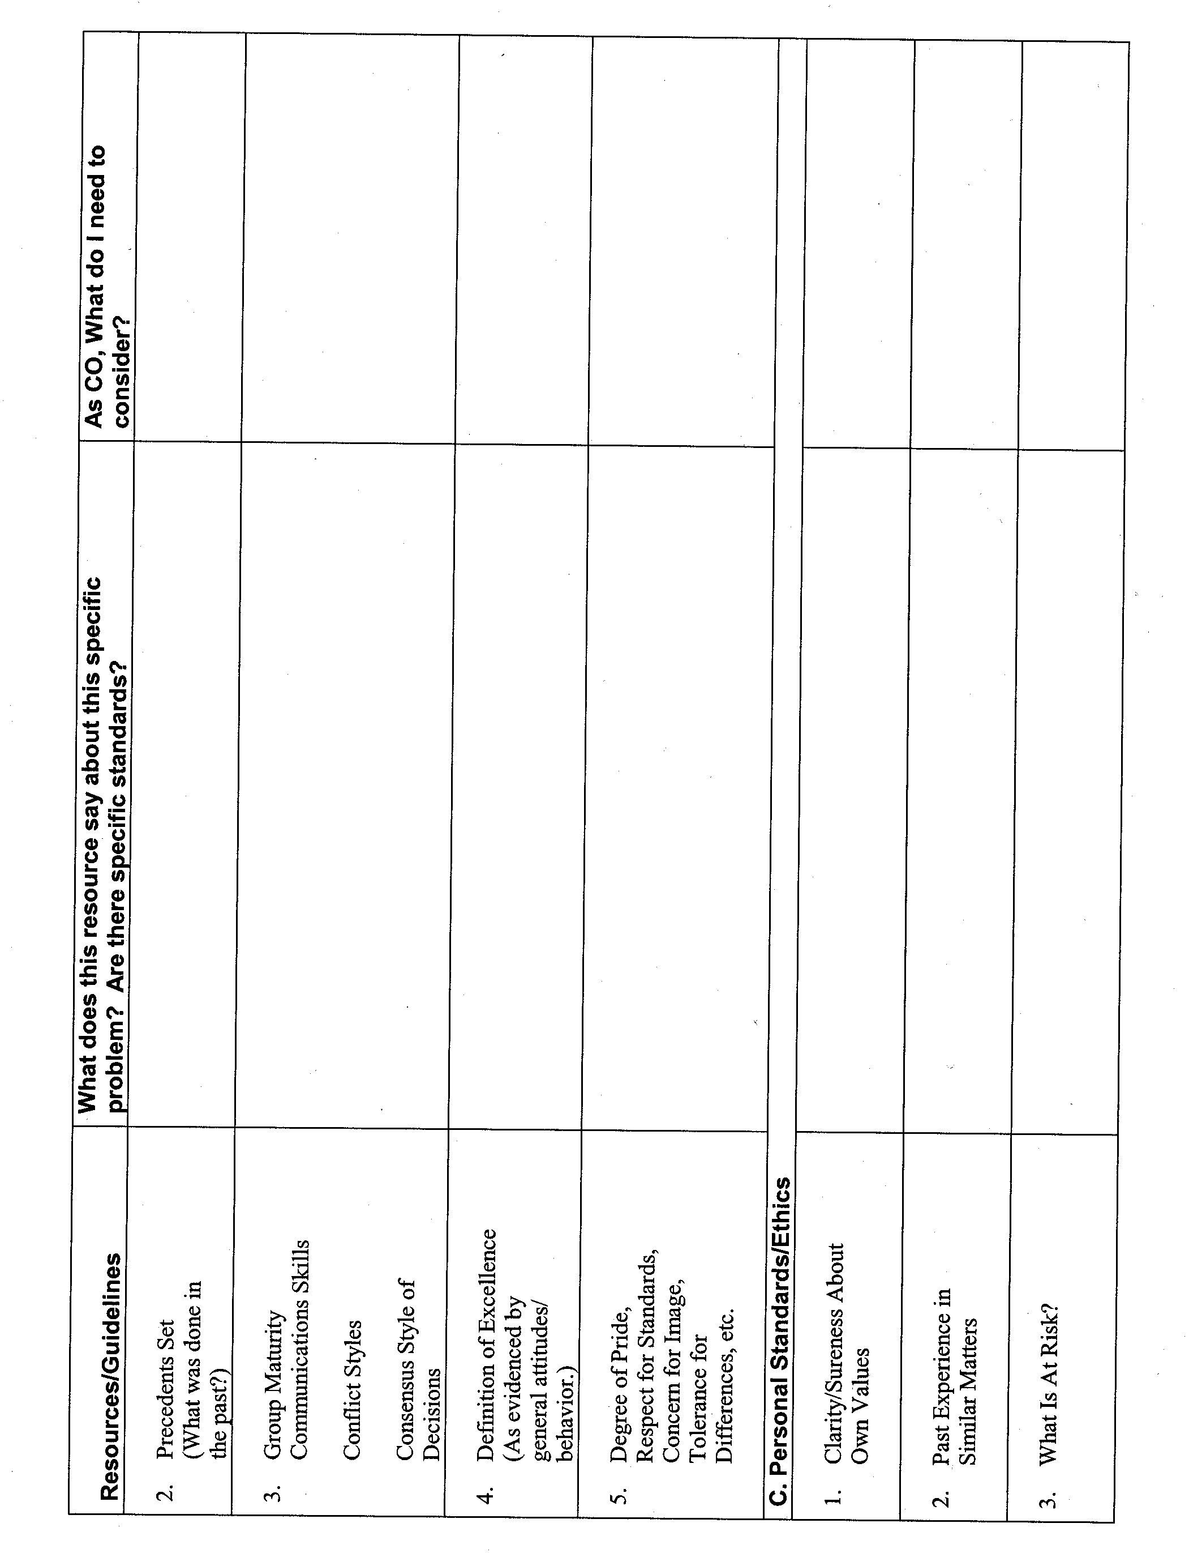
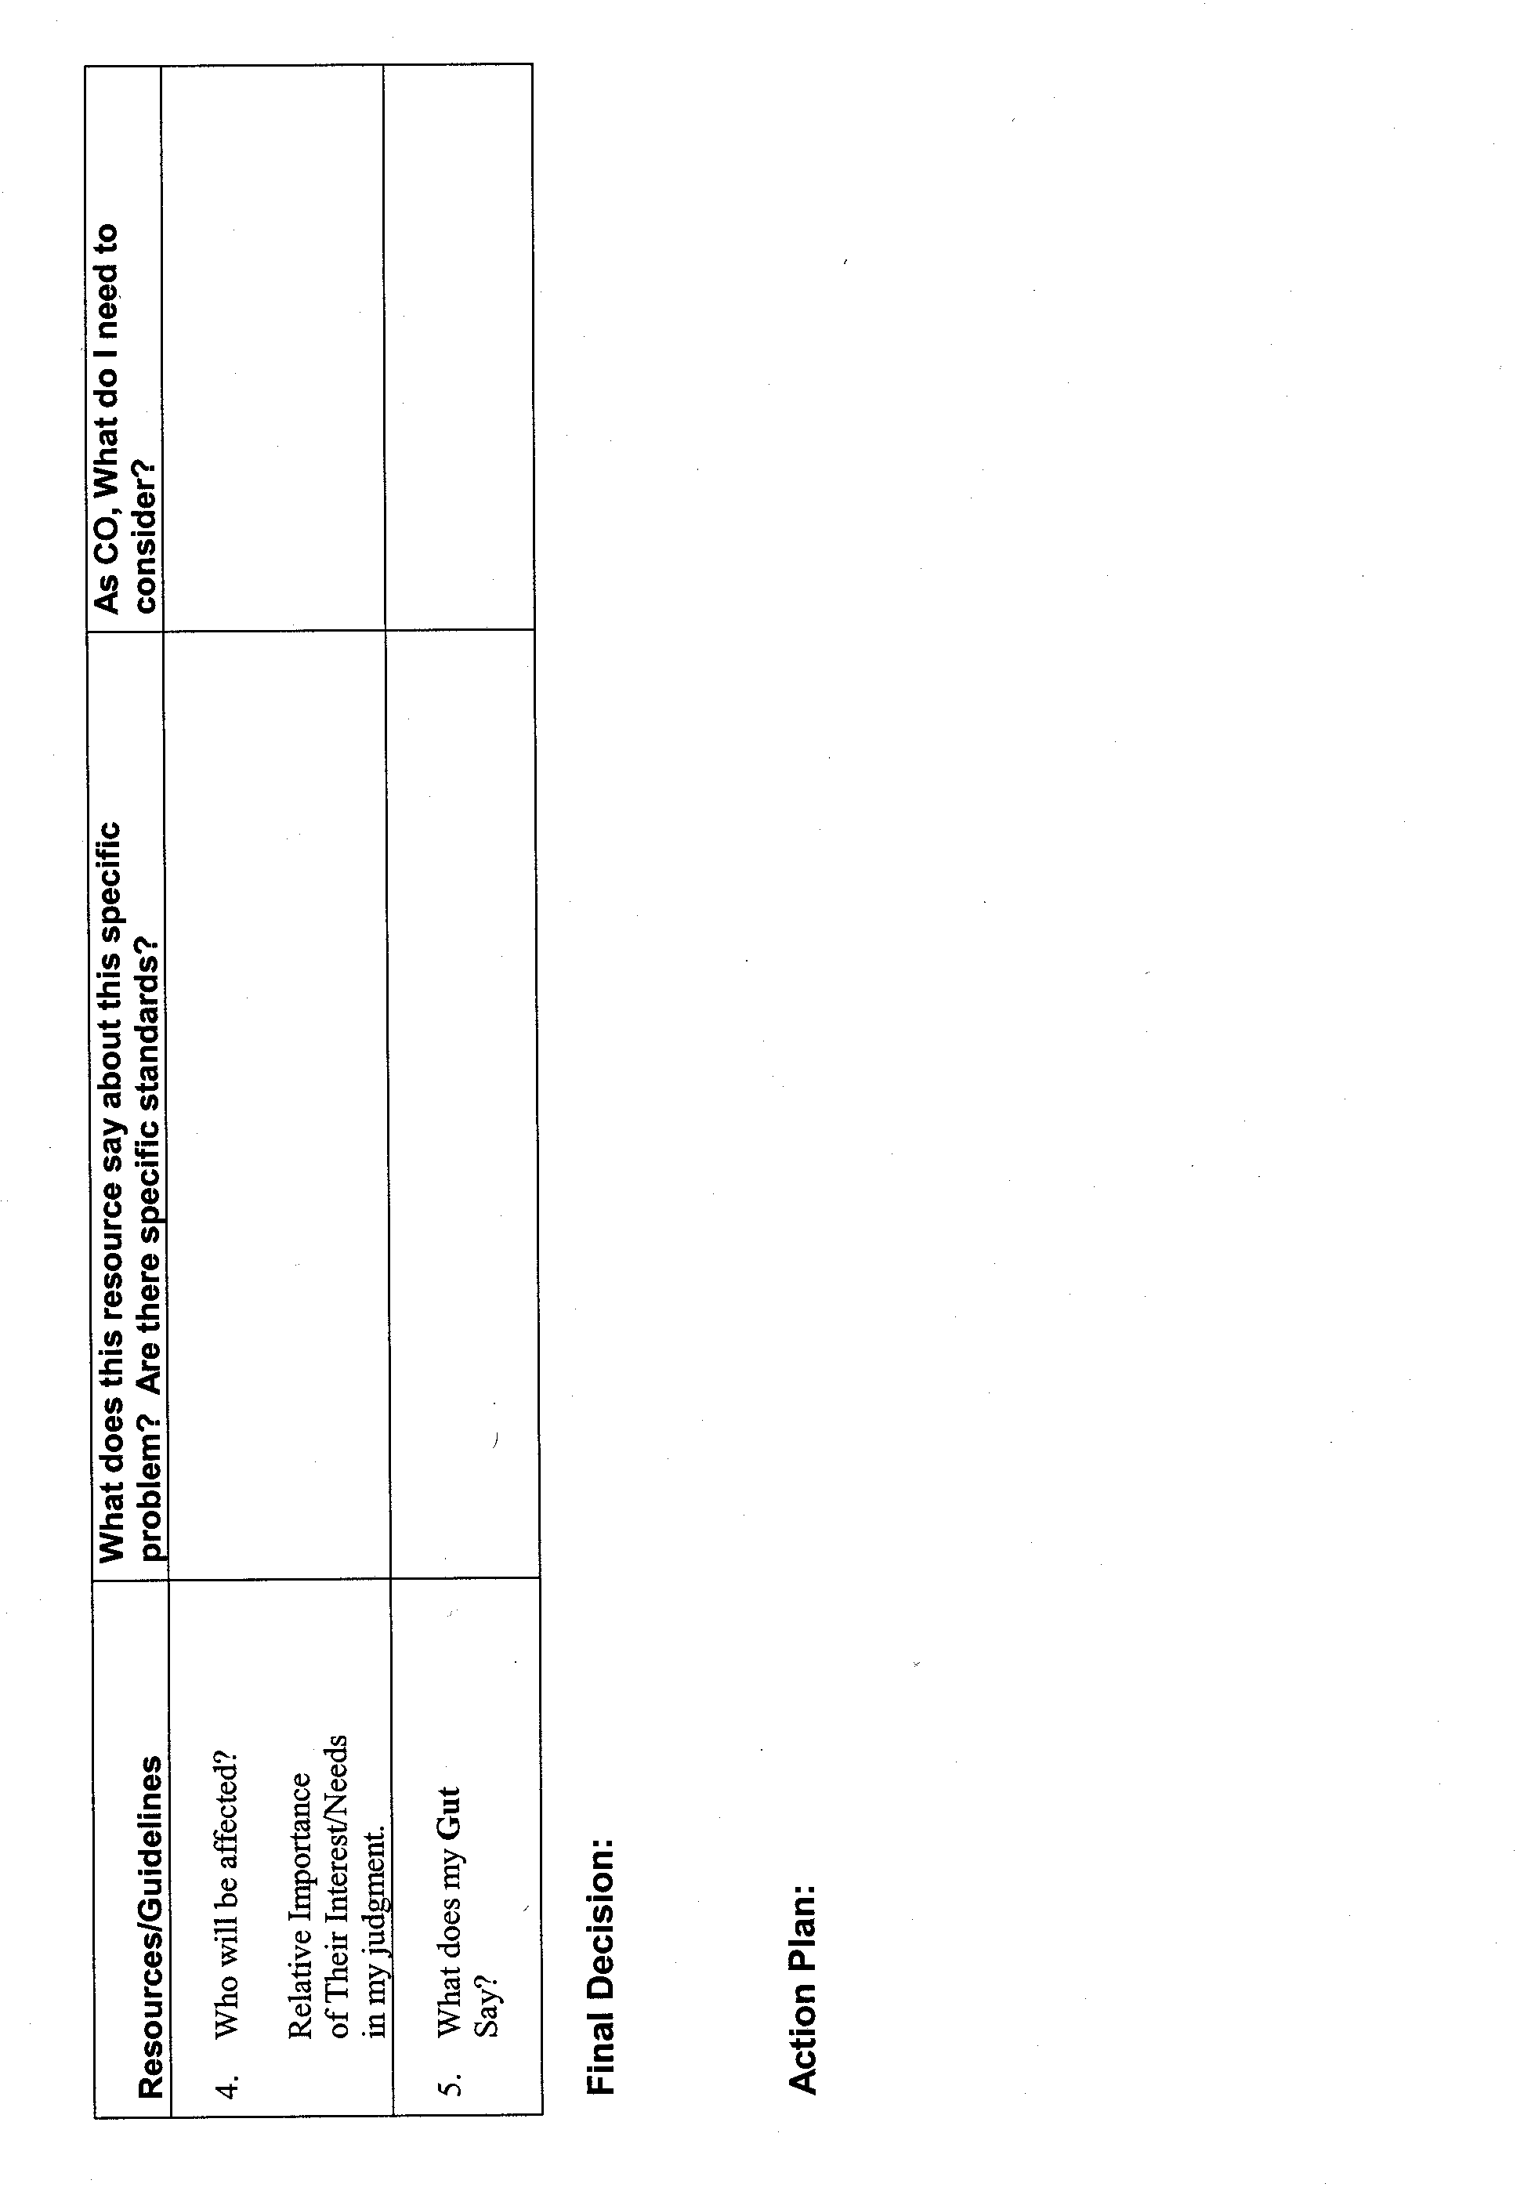
Glossary
CHECKLIST FOR ETHICAL DECISIONS

1. Ethics--A given system of conduct; rules or standards of behavior.

2. Code of Ethics--A published set of specific guidelines for members of a profession, organization, etc., which delineates correct and/or expected behaviors.

Appendix A

TWENTY-FIVE situations for

activity ET.3

Situation #1

After much soul searching and debate, your volunteer department Board of Directors made a policy decision to not fight fires at properties for which the annual fire dues are not paid. They have instructed fire personnel to carefully monitor which properties in the community are paid or unpaid, and to act accordingly. They believe that if people in the community think the fire/EMS department will respond anyway, fewer people will pay dues, and the department will not have the revenues it needs to operate.

You and your crew have just been dispatched to a structure fire. Just as you arrive, the dispatcher tells you that the annual dues are not paid. Your initial size up shows a working fire in the garage and fire just entering a short breezeway connecting the garage to the house.

Do you:

- Immediately leave the scene?

- Perform rescue and salvage, and protect neighbors' exposures only?

- Prepare to pump water, lay lines, and wait for more instructions (but not begin the fire attack)?

- Fight the fire aggressively?

- Other? Please specify.
Situation #2

You are the fire marshal of the department. After extensive negotiation with a contractor over a plans check problem, you finally resolve all of the problems. The contractor did not want to sprinkler the building, yet it was oversized. A compromise was achieved by installing division walls. This was accomplished by your suggestion only after weeks of disagreement.

A week later when you arrive in the office, you discover an envelope on your desk. Upon opening it, you discover two tickets to a professional game and a note. It states, "Thanks for all your help."

Do you:

- Take the tickets to your superior's office and report them to him?

- Call the contractor up and ask him to come over and take the tickets back?

- Throw the tickets away and don't mention it to either your superior or the contractor?

- Use the tickets for the game?

- Other? Please specify.

Situation #3

You are coming home from a meeting late at night and you are in your personal vehicle. As you are waiting at a light, a vehicle pulls up beside you and you observe an offduty Captain from your department driving the car. The Captain has been paying attention to the passenger in the car and has not noticed you. They are embracing in a very amorous fashion. As the light changes, the driver straightens up and you recognize the passenger as the significant other to the onduty Captain at your station. Both appear to have been drinking.

Do you:

- Honk your horn, get their attention so they can see you and then drive off?

- Honk your horn, get their attention, motion the vehicle to the curb, and warn them right there of the consequences of the actions?

- Allow them to drive off unaware of the fact that you observed them, then talk to the driver later when the driver is on duty?

- Allow them to drive off unaware of the fact that you observed them, then forget the entire matter?

- Other? Please specify.

Situation #4

You are the department Training Officer. A person walks into your office and shows identification as a Federal Bureau of Investigation (FBI) agent. The agent has a warrant for the arrest of one of your new recruits. The warrant is for narcotics trafficking with high school students. The recruits are due to graduate in 3 days. The recruit in question is number one in the class in performance. The chief is out of town and unavailable. The agent wants the recruit brought to the office. Currently, the recruit is on the drill tower.

Do you:

- Immediately contact the local police department and ask them to accompany or meet you at the drill tower?

- Go to the tower yourself, pick up the recruit in question, and return the recruit to the FBI agent without saying what's happening?

- Go to the tower yourself, remove the recruit from class, suspend the recruit from duty pending an investigation, and take the recruit to the agent at headquarters?

- Ask the agent to accompany you to the tower, remove the recruit from class, and turn the recruit over to the agent?

- Other? Please specify.

Situation #5

Traditionally, your fire/EMS department has had a keg of beer in the recreation room of the department, which also serves as a department meeting room. Department members tend to gather and socialize in this spot at the back of the station and there has never been any real trouble over "having a few beers." Recently, a driver operator had a minor accident while driving the engine to a grass fire. There were no police officers on scene, so the driver was not cited, but the rumor got out that the driver was "drunk."

In yesterday's local newspaper, an irate letter was printed, accusing the department of encouraging "drunk and dangerous" driving by serving liquor. You are a senior member of the department, responsible for driving and safety standards.

Do you:

- Ignore the letter?

- Request a policy decision about alcohol on the premises?

- Move the keg of beer out yourself?

- Create a committee within the department to make a decision?

- Other? Please specify.

Situation #6

One night you are sitting in your office doing paperwork. A young firefighter/EMT enters your office and requests permission to speak to you. The firefighter/EMT proceeds to inform you of preference to an alternative lifestyle and is concerned about word getting back to the department of an incident where this individual was arrested at a demonstration for gay rights.

Do you:

- Counsel the person, suggest psychological help, and then wait and see what happens next?

- Get all the facts, then immediately contact your superior for guidance?

- Based on the facts, immediately suspend the firefighter/EMT pending further investigation?

- Inform the firefighter/EMT that department policy requires all arrests, either on or off duty, to be promptly reported. Give the firefighter/EMT 24 hours to do the same or face being suspended pending an investigation.

- Other? Please specify.

Situation #7

As the onduty Battalion Chief, you are about to leave the station when you observe an off-going Captain remove a toolbox from a pickup and place the box in a car. Three shifts later, you overhear the Captain who owned the pickup complain that someone had stolen the toolbox from the truck.

Do you:

- Assume it's a practical joke and ignore it?

- Speak up and tell the Captain what you observed?

- Don't say anything right then, but talk to the Captain who moved the box and tell what you observed?

- Get all of the Captains together and discuss the missing toolbox?

- Other? Please specify.

Situation #8

Your fire chief has been quoted in the media, saying that fire prevention, including an aggressive fire inspection program, is the department's highest priority. You did a careful review of all the public assembly and commercial occupancies within your station's boundaries, and developed a prioritized annual inspection plan.

You gave highest priority to some older, low-income apartment buildings, businesses with stored hazardous materials, several old church properties used for bingo and dances (as well as religious services), and an old warehouse converted into an artists' cooperative.

You began the inspection after training your crew and discovered that it's slow going because you are finding numerous, serious violations, and it takes time to do a thorough job.

Yesterday, your Battalion Chief called you in and said, "I know you're taking the inspection program seriously, but you'll have to put your action plan on hold. For the next 6 months, we'll only be doing revenue-producing, low-hazard, "quick and dirty" inspections. The city manager gave the word to the chief!

Do you:

- Rewrite your inspection plan, targeting low-hazard but revenue-producing occupancies as targeted by the Battalion Chief?

- Point out the contradiction between the mission and department priorities, and the new orders about inspections?

- Tell the Battalion Chief that in good conscience you can't change the plan?

- Quit doing inspections until they make up their minds?

- Other? Please specify.

Situation #9

One morning a structure fire call comes in about 5 minutes after shift changes. As Battalion Chief, you arrive on the scene of a fairly smoke-charged structure. No fire is visible, but there's a lot of smoke. The Captain is sitting on the curb, head between knees and has vomited in the street. The engineer is running the fire. Upon closer examination, you determine that the Captain is experiencing a severe hangover and you smell alcohol. The Captain is a 30-year veteran, your former supervisor, and going through a divorce.

Do you:

- Order the Captain to straighten out and get back into his job?

- Order the Captain off the fire and to get into your vehicle?

- Advise the Captain of being suspended and to remain seated in the vehicle until the fire is over?

- Ignore the Captain and work with the engineer to get the fire out?

- Other? Please specify.

Situation #10

A late night wreck occurs. Upon arrival, you discover that one of the victims is the child of an onduty firefighter/EMT. The child is badly injured and probably won't live. The child goes into surgery immediately.

Do you:

- Try to reach the child's other parent to inform the firefighter/EMT?

- Send someone to relieve the firefighter/EMT and have that person driven to the hospital in a fire/EMT service vehicle?

- Personally go to the firefighter/EMT and report the incident and allow the firefighter/EMT to drive to the hospital?

- Talk to the firefighter/EMT and suggest remaining on duty until 0730 shift change because the child is in surgery anyway?

- Other? Please specify.

Situation #11

The firefighter/EMT union has voted to strike. You agree that compared to neighboring departments, you are underpaid. The negotiations have brought unrest to the city. A firefighter/ EMT strike in this State is illegal.

Do you:

- Go out on strike if necessary?

- Ignore the strike vote and remain on the job?

- Report to work, but function only to save lives?

- Take annual leave and leave town if a strike vote passes?

- Other? Please specify.

Situation #12

You are about to leave to go to an oral board for entry-level firefighter/EMT in a neighboring community. One of your contemporaries, who is also a social acquaintance, asks to speak to you advising you that a family member's sibling is to be one of the candidates you will be rating. You are asked to give the sibling an extra "little boost" if you get the chance.

Do you:

- State that this is out of line and that you will not even rate the candidate after that request?

- Acknowledge the request, but disqualify yourself when the candidate is heard?

- Disregard the request as being well-meaning but misdirected. Grade the candidate anyway?

- Ask for more information about the candidate so you can make a more informed decision?

- Other? Please specify.

Situation #13

The significant other of one of your engineers calls you. Tells you that your engineer is an alcoholic and is abusive and warns that if the behavior doesn't stop, the significant other will go to the police, and it may result in your engineer being out of a job.

Do you:

- Advise the significant other that this is a personal matter and that you cannot get involved?

- After getting the facts from the significant other, give counseling on where to get additional professional help?

- Talk to the engineer, advise that you know of the problem, and warn of the consequences?

- Counsel the engineer about employee assistance programs, and other options available to help get through this crisis?

- Other? Please specify.

Situation #14

While you are off duty, you stop at the scene of an accident. You notice that a victim who needs cardiopulmonary resuscitation (CPR) has obvious purple facial spots, possible Kaposi's Sarcoma (an AIDS indicator). An ambulance has just been called (estimated time of arrival (ETA) 7 minutes), and you appear to be the only trained person on scene.

Do you:

- Avoid giving CPR, and find other things to do on scene (look for other victims, etc.)?

- Take command. Ask if anyone knows CPR, and ask them to perform it on the victim (without mentioning the facial spots)?

- Perform routine CPR?

- Clear the airway, and perform chest thrusts, but not give mouth-to-mouth resuscitation?

- Other? Please specify.

Situation #15

You are a firefighter/EMT service professional with a contracting business that you conduct "on the side." Your main work is installing security gates and grates on doors and windows to protect property owners from burglars. Your biggest seller is a wrought iron combination window grate that bolts on and is not easily or quickly removed.

Other available products have a panic bar release on the inside so that people can release the window grates during a fire. However, these are very expensive, difficult to install, and require some maintenance and routine testing. You realize that if you carried them in stock, it could be very costly, and few property owners could afford them anyway.

Do you:

- Continue offering only the profitable permanent gates and grates?

- Invest in marketing and testing of the panic release only to see if there is interest in them?

- Purchase a basic stock of the better grates and actively encourage property owners to buy them?

- Absorb the cost of a major campaign (media, etc.) to educate people about the safety features of the release type? (Invest time and money in public education?)

- Other? Please specify.

Situation #16

A major hotel's manager asks you to take an informal look at a new conference room design. As you leave, you are given a gift certificate for the free use of the workout room, sauna, and pool "anytime you want" by you and the other two Captains at your station.

Do you:

- Give thanks but state you cannot accept gifts, and leave?

- Take the certificate, but report it (as a gift) to your senior officer?

- Take the certificate, but not use it and not share it with your peers?

- Give the certificate to the other two Captains, telling them they can decide for themselves whether to use it?

- Other? Please specify.
Situation #17

You observe that another officer, who is a newly-promoted Captain, is not getting the support and resources that counterparts routinely get. You have heard a Battalion Chief say "let's see if the new Captain can carry the ball."

Do you:

- Quietly share information with the new Captain to help out?

- Enlist other Captains for support and to assist the new Captain to succeed in the position?

- Ask your Battalion Chief to talk to the other Battalion Chief about changing personal attitude and practices?

- Do nothing but wait and watch?

- Other? Please specify.

Situation #18

You are a Lieutenant/Paramedic, in charge of a three-person crew at your station. Things are going well for you--the crew has accepted your leadership, and usually functions well as a team.

Recently, things have started disappearing at the station. Food disappears out of personal food lockers in the kitchen, and out of the refrigerator. DVDs on loan from station headquarters are not there when you need them for training. An expensive new training manual has also disappeared. The Captain tells you bluntly that the thefts appear to be happening mostly on your shift, and that you must solve the problem. You think about the problem for a few days.

Do you:

- Call your crew together and tell them thefts will not be tolerated, and that you expect everyone to respect the property and rights of others?

- Suggest that everyone place their own locks on personal lockers, etc.?

- Prepare a purchase order for the Captain's approval for locks for all cabinets at the station?

- Lock your own lockers, but say nothing to the crew?

- Other? Please specify.

Situation #19

You are a State certified fire instructor who uses copyrighted material in your seminars. You have been contacted by a rural volunteer fire company for help in your special area of expertise. This company is extremely underfunded due to local economic conditions. There are no funds available to purchase any of the standard materials that you use for training.

You are willing and desirous of helping this organization.

Do you:

- Tell them that you will only present the program if they cover the cost of the materials?

- Violate copyright laws by photocopying materials for this group?

- Reduce the quality of the program significantly, by not using the copyrighted materials?

- Pay for the materials yourself (approximately $50)?

- Other? Please specify.

Situation #20

You dislike your superior intensely. Although technically your superior is well trained, your superior's personal ethics prevent your superior from being respected. The superior is dishonest and disloyal to the department. The superior often distributes flyers and hangs posters, which are offensive to many department members. The superior recently made a decision that negatively affected you personally.

Totally by accident, you discover that your married superior is having an affair with one of the department's employees.

Do you:

- Mind your own business and ignore the problem?

- Tell your superior what you know and ask the superior to reconsider a recent decision?

- Send an anonymous note to the spouses of your superior and the other employee advising them of the problem?

- Start a rumor at city hall about their affair. Try to get this information to the City Manager?

- Other? Please specify.

Situation #21

As a fire investigator you sought and won a conviction of arson of a suspect you believed started a fire in a warehouse. The suspect has been placed in the State penitentiary. After 6 months you personally uncover evidence that casts doubt in your mind about the suspect's guilt.

Do you:

- Forget about it, and let the suspect finish the sentence?

- Continue to pursue the evidence, but don't tell anyone else about the discovery?

- Tell your superior and be guided by decision?

- Take this new evidence to the district attorney, and request that the case be reopened?

- Other? Please specify.

Situation #22

While you are off duty, you injure your back lifting something in your garage. You do not have disability insurance. The first few minutes after reporting to duty on one of your shifts, you have a working fire, and although you were not hurt, you were involved in a lot of heavy work.

Do you:

- File a compensation claim just to cover yourself?

- File a compensation claim based on the fact that the fire aggravated your injury?

- Consult with a lawyer and determine what your rights are?

- Forget about the claim, but advise your superior of the problems and request assignment to lighter duty?

- Other? Please specify.

Situation #23

One of your firefighter/paramedics has requested approval to attend a special conference/class/ seminar. You know that this person violates rules and regulations, has a poor record of attendance, and generally is not a productive team member. However, the individual makes it clear to you that refusal to endorse the request will be interpreted as discrimination. You are also sensitive to the fact that if this individual attends the conference, people who are more deserving cannot attend, and will be penalized unfairly.

Do you:

- Endorse the application without comment?

- Endorse the application after counseling the officer about your expectations for performance improvement after the conference?

- Refuse to sign the approval, and explain why?

- Refuse to sign the approval without comment?

- Other? Please specify.

Situation #24

You are the Deputy Chief in your fire agency. You have always been a team player and have a well-deserved reputation for being loyal to the organization and your fellow firefighters/EMTs.

Over the past two years you have perceived a serious decline in the overall morale and motivation of the department. Various members of the department have confided to you that your superior (the Fire Chief), a close personal friend, has been "playing favorites." You have checked this out and found that it is not only true, but that on numerous occasions, people have not been disciplined even when major violations of policy, contract, or even illegal deeds have occurred.

Do you:

- Go to the Fire Chief and tell him/her of your findings?

- Go to the mayor or Board that supervises your Fire Chief?

- Keep quiet and hope that things will change?

- Document what you have learned, and file it in a safe place?

- Other? Please specify.

Situation #25

You are a captain and go out to dinner with your spouse and some close friends. After you are seated and order your dinner, you walk through the restaurant to use the restroom. On the way, you notice a serious fire code violation: an exit door is chained and locked and a display table is placed in front of it.

Do you:

- Decide that since you are on personal time, you'll do nothing?

- Return to your table and tell the group that you are all leaving and going to another restaurant?

- Seek out the manager and insist that they unchain the door and remove the obstruction?

- Call the senior firefighter/EMT officer currently on duty and report the violation?

- Other? Please specify.

Appendix B

Example Checklist for Ethical Decision
