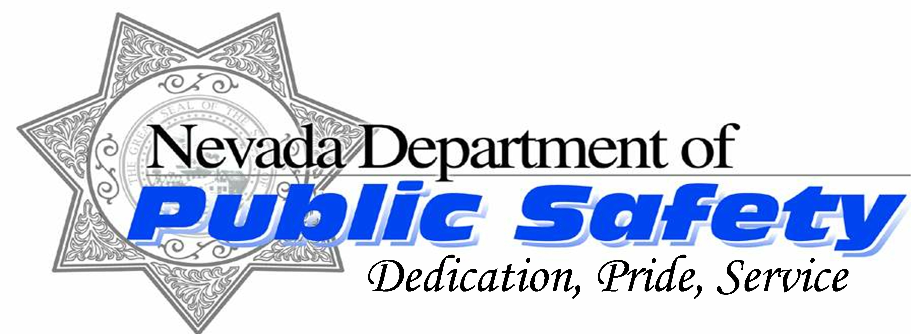

State Fire Marshal Division

Fire Extinguisher Survey

This survey is to be completed by any agency or business when a fire extinguisher is used in the event of a fire whether successful or not in putting it out. Our intent is to show the effectiveness of fire extinguishers as a deterrent to a fire getting out of control. This data will be used to complement the National Fire Incident Reporting System (NFIRS) annual report for Nevada. As with all fire incidents use common sense and get out as quickly as possible if you are not able to contain it with a fire extinguisher. Safety first!

Name of User:

Name of Company/Agency:

Address:

Zip Code: | Work Phone Number: | Cell Phone Number:

What type of Extinguisher was used?

What was burnt or burning?

Was the attempt to control the fire with an extinguisher successful? Yes No

If “No” what were the reasons it was not contained? (Example; extinguisher not charged and would not dispense or fire to big for size of extinguisher etc..).

Address where fire occurred:

Zip Code: | Did a Fire Department Respond? Yes No

Do you know the name of the Fire Department? | please enter here:

Estimated damage costs?

Please email this survey to: sfm@dps.state.nv.us

Put Extinguisher Survey in subject line.

Thank you for your help and assistance!

